Step and Frequency Response of a Motor-Flywheel System
Touchton, Noah
Section 12105 Date 9/25/25

Abstract—The objective is to determine whether a motor–flywheel can be approximated by a compact first-order model that maps applied voltage to rotational velocity, and to quantify its gain K and time constant τ. A sinusoidal frequency sweep was used to estimate magnitude and phase at discrete frequencies and assemble a Bode response; a time-domain step test provided independent estimates by measuring steady-state changes in velocity per volt and the 63.2% rise time. Command values were converted to volts using the DAQ scaling, and measured velocity (deg/s) was converted to rad/s. Because the electrical dynamics are faster than the mechanical dynamics over the test band, a first-order form is appropriate. Both methods yielded closely agreeing parameters (typical values K≈1.13–1.16 rad/(s⋅V), τ≈0.03–0.035), producing similar model responses that match the low-frequency data well. The experimental Bode magnitude rolls off more steeply at high frequency, consistent with an additional measurement low-pass (from filtered/differentiated velocity), while the first-order model remains valid in the low-to-moderate frequency range (corner near ωp≈28–33).
Index Terms—Bode plot, DC motor, first-order system, system identification.

INTRODUCTION
T
HE objective is to implement and compare two different type of closed loop controllers. bang-bang and PID, to control the rotation of a motor-platen system. The bang-bang controller is implemented with a deadband and an effort level. The PID controller will be manually tuned as well as tuned using desired overshoot and settling time specifications to solve for the control constants. The goal is to compare each controller’s performance quantitively to explain why differences occur based on control theory and system behavior.

Dynamic System
In this lab the motor flywheel system relates an input voltage to an output rotational velocity. Understanding how to relate a voltage to a velocity is how the system can be controlled.
The electrical dynamics relates voltage V, resistance R, current i, inductance L, and back emf e to each other through (1).
$$V=iR+L\frac{di}{dt}+e$$ | (1)

The mechanical dynamics of the system relates the torque, T of the motor to the moment of inertia J, and rotation angle θ, of the flywheel through (2). The shaft will also have motor friction, b_{m}.

$$J\ddot{θ}=T-b_{m}\dot{θ}$$ | (2)

Back- EMF arises from the motor’s rotation in its magnetic field and is proportional to angular velocity through k_{e}. This generates a magnetic field which puts energy back into the system. This means that the back-EMF, e is related to the speed of the motor shown in (3). These relations couple the electrical and mechanical dynamics though the shared variable $= \dot{}$. The torque and current are also proportional as shown in (4)

$$e=k_{e}\dot{θ}$$ | (3)

$$T=k_{t}i$$ | (4)

Transfer Functions
Transfer functions relate the input and output dynamic relationship into an algebraic ratio in the Laplace domain, turning differential equations into a form that is easier to manipulate. With the motor voltage V(t) as the input and the angular velocity ω(t) as the output, taking the Laplace transform (with zero initial conditions) and using the known motor relations shown in (3) and (4) yields the voltage to velocity transfer function (5). This can be used to easily generate what the output will look like. In order to avoid an extra integrator, voltage will be related to the derivative of angular position, ω. The poles of a transfer function are where the denominator is equal to zero. In this case there will be two poles because the denominator is a second-degree polynomial.

$$\frac{Ω(s)}{V(s)}=\frac{k_{t}}{\left(Ls+R\right)\left(Js+b_{m}\right)+k_{t}k_{e}}$$ | (5)

This choice of angular velocity avoids adding an extra 1/s term in the transfer function. Over the frequency range used in this experiment, a first-order approximation is appropriate because the electrical pole is much faster than the mechanical pole over the test band. Over our test band, the electrical time constant is much smaller than the mechanical one, so we can neglect L. This turns our transfer function into a first-order transfer function for which it is much easier to compute the unknowns. The first-order system can be expressed with a gain, K and time constant τ as shown in (6). There will be only one pole in this first order approximation, and it will be proportional to the time constant as shown in (7).

$$\frac{Ω(s)}{V(s)}=\frac{K}{τs+1}$$ | (6)
$$ω_{p}=\frac{1}{τ}$$ | (7)
Control Methods
Using control theory, controllers can provide an input signal into the system to achieve a desired output. The controller takes into account the error between the actual signal and the desired output to determine the input signal. Two types of controllers were used in this lab: Bang-Bang and PID.

Bang-Bang Controller
A bang-bang controller is a simpler controller. The controller provides a fixed signal in the direction opposite of the error. The fixed signal is based on the effort level chosen for the controller. If the error is positive the controller will provide a positive signal until the error is no longer positive and vice versa. The deadband is implemented to prevent the controller from providing an input when the error is close to zero. When the error is within the designated deadband the controller will not provide an input. This prevents excessive oscillation and the performance of the bang-bang controller depends on the chosen effort level and deadband.

PID Controller
A PID (Proportional-Integral-Derivative) controller builds on the bang-bang controller by changing the input based on things like the magnitude and rate of change of the error. The proportional term works very similarly to the bang-bang controller but the magnitude of the input scales with the magnitude of the error. The integral term accumulates past error trends to eliminate long term bias. The derivative term attempts to predict future error using the rate of change of the error and attempts to counteract it. Tuning these three constants allows for a trade-off between speed, overshoot, and stability. These constants can be manually tuned as well as calculated from desired response parameters.

Ackermann Method
The Ackermann Method is a method for finding the PID gain constants using mathematical models. State-space models are generated from the transfer function of the system finish this.

State Space Modeling
State space modeling is a method of representing systems in a way that makes it easy to perform calculations and observe their behaviors. It utilizes matrices to handle multiple inputs and outputs. The coefficients of the matrices come from the dynamics of the system. The general equation used relates the state vector x to the input u as shown in (8).

$$\dot{x}=Ax+Bu$$ | (8)

Methods

Hardware
This lab uses a Data Acquisition Device (DAQ) that is attached to a brushed DC motor coupled to a flywheel. The motor is connected to a 12V power supply and the DAQ can produce an integer command which ranges from -1023 to 1023 that is mapped on to whatever voltage the motor is supplied with. The DAQ can also give a binary direction command to tell the motor which direction to spin. The shaft angle was measured with a quadrature encoder, and the rotational velocity was obtained by filtering the angle and differentiating.

Software
A LabVIEW VI was constructed with a signal generator that can produce sine and square waves at a user-set amplitude and frequency. The VI can also compute velocity from the measured angle and write time-stamped records to a text or Excel file.

A custom Python script was used to process the data. The script was capable of scraping all the data from the Excel sheet and generating all the desired values. The code converts the command to voltage, segments the long sine-sweep file into frequency segments, fits sinusoids to input and output at each block’s test frequency, assembles the Bode plots, detected step transitions in the square-wave file, and computes the gain/time constants. The script is then able to plot a Bode plot based on the approximated transfer function. The script exports easy to read png files to visualize all the data.

Procedure
First, the turn on command was set. This was set by running the VI with amplitude of 500 and frequency of 0.25 Hz and increasing the value of the turn on command until the data looked sinusoidal.
The sine sweep data was collected by choosing a sine wave at a set amplitude and then taking data at multiple frequencies between 0.05 Hz and 20 Hz. For each frequency the data was recorded for several cycles to ensure the full range of the frequency was recorded.
The time response was done by choosing a square wave at 0.2Hz and recording several positive and negative steps on this frequency.

Calculations
The sine sweep file was split into each frequency segment automatically by the Python script. The code takes all the voltages and velocities for each frequency and does a least squares regression to find functions that model them. This allows the gain and phase estimations to be very accurate since it eliminates the outliers. The ratio of amplitudes of these waves can be used to calculate the gain and the difference in phase angles can be used to calculate the phase plot of the Bode graph. The script does this for all frequencies and plots them on a logarithmic scale to create the Bode plot.

For the square wave, script first finds the edges and separates them. Then, it computes the ratio of velocity change to voltage change in each step to find K and the time constant by measuring how long it takes to reach 63.2% of the total response.

Using the calculated DC gain and time constants for the two methods, those values are plugged into the transfer function and graphed on top of the Bode plot and step response plot to compare. The transfer function that was plotted was in the form of (6). A state space model was created to easily represent the system as shown in (9). Python was used to plot the transfer function.

$$\dot{x}=-\frac{1}{τ}x+\frac{K}{τ}u$$ | (9)

Units and Scaling
To find the proper voltage the script must convert the command into voltage using the integer command factor as well as the voltage of the motor. The command will be from -1023 to 1023 so this scaling factor can be used to find the voltage. The LabVIEW software also outputs the rotational velocity in degrees per second so the script must convert this to radian per second.

Results
Step Response
A low-frequency square wave was used to generate a repeated step motor response of amplitude 250 (command). For each edge, pre and post plateau medians were taken of the input voltage and output velocity giving the steady state change in V and ω. These values were used to calculate the DC gain K. The time constant, τ was found by finding the 63.2% time between plateaus. Table I shows K and Table II shows τ for each step.

TABLE I
DC Gain for Each Edge
Step # | Value | Units
1 | 1.129 |  | rad/(s*V)
2 | 1.134 |  | rad/(s*V)
3 | 1.128 |  | rad/(s*V)
4 | 1.137 |  | rad/(s*V)
5 | 1.131 |  | rad/(s*V)
6 | 1.138 |  | rad/(s*V)
7 | 1.131 |  | rad/(s*V)
8 | 1.134 |  | rad/(s*V)

TABLE II
Time Constant for Each Edge
Step # | Value | Units
1 | 0.03553 |  | s
2 | 0.03480 |  | s
3 | 0.03614 |  | s
4 | 0.03524 |  | s
5 | 0.03440 |  | s
6 | 0.03623 |  | s
7 | 0.03475 |  | s
8 | 0.03687 |  | s

Frequency Response
A sweeping sine wave at constant amplitude of 250 (command) was measured at different frequencies to find the gain and delay in response for each frequency. The amplitudes and phase of the input and outputs were calculated and used to find the DC gain and the time constant shown in Table III.

TABLE III
DC Gain and Time Constant for Frequency Response
Variable | Value | Units
K | 1.163 |  | Rad/(s*V)
τ | 0.02995 |  | s

TABLE IV
DC Gain, Time Constant, and Pole for Both Responses
Method | K [rad/(s*V)] |  | τ [s] | ω_{p} [1/s]
Step | 1.13 | 0.0300 |  |  | 33.33
Bode | 1.16 | 0.0354 |  |  | 28.25

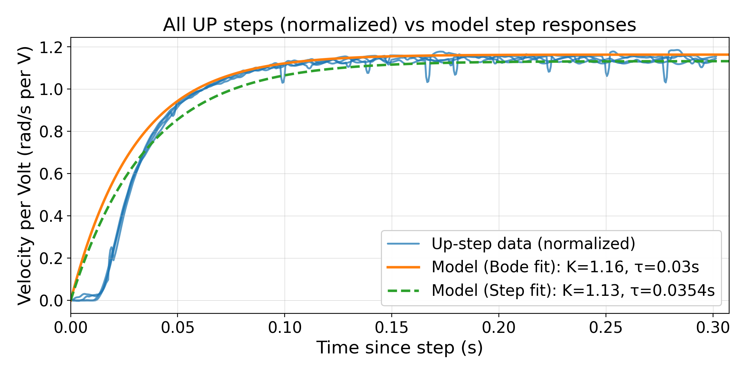
Fig 1. This figure plots all the step responses that were increasing alongside the model step responses for the Bode and Step fit.

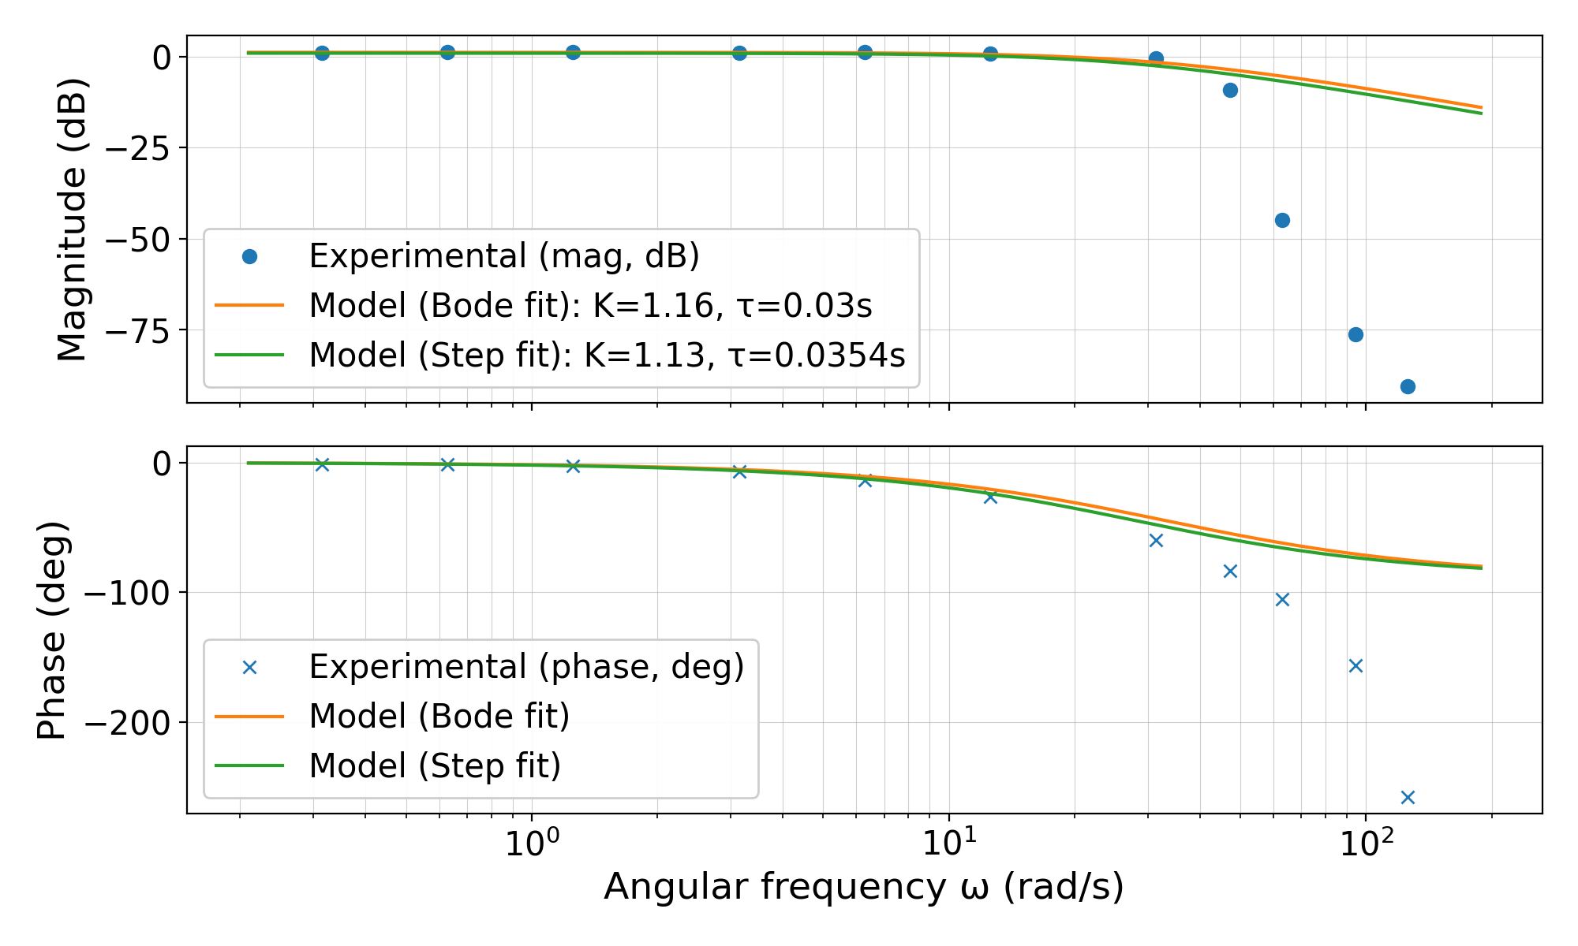
Fig 2. This figure plots the Bode Plot values generated from the frequency response as well as the model frequency responses from the Bode and Step fit.

Models
Fig 1 and Fig 2 show the models generated from the experiment data. The orange line in both figures represents the model made from the calculated gain and time constant from the frequency response while the green line represents the model made from the calculated gain and time constant from the step response.

Discussion

The goal of this lab is to see if the motor flywheel system can be approximated as a first-order system. A first-order transfer function was generated using two methods. The first method was exciting the system at different frequencies to record the sinusoidal response, and the second method was providing a repeated step input to observe the systems long term response. Both methods provided a gain and time constant that could be used to create a transfer function to compare to the raw data.

The two methods produced similar gains and time constants leading to similar models. For the gain, the frequency model was 2.65% larger and the time constant was 15.24% larger than the step model shown from the data in Table IV. This bias matches what is shown in the Bode plot. Both models are reliable below 20-25 rad/s.

Overall, the data matched the models well. In the step response shown in Fig 1, the positive step response data aligns very well with the plot of the transfer function. Since this data was taken at a constant low frequency this makes sense because at low frequencies the second pole is not significant compared to the first. At the beginning of the graph the experimental data is flat and has a delay before it starts to climb like the models. This is likely since the motor was spinning in the opposite direction when it received the step input. There was a small delay due to the momentum in the other direction. Most of the experimental data lies between the two models.

In the Bode plot shown in Fig 2, the experimental data matches the models well until the first pole. Both models start to decrease at the first pole where the experimental data decreases, but the experimental data decreases much faster. That is because there is a second pole that can only be observed at the higher frequencies that the model is not considering. The velocity is generated by differentiating the filtered angle measured by the sensor. This differentiation introduces an additional low-pass pole in the measured output. Each pole increases the slope of a Bode plot by -20dB/dec magnitude slope and -90-degree phase so these additional poles are not considered in the model. Both effects combined explain why the model does not decrease as quickly as the experimental data does on the Bode plot. When the system is running at higher frequencies there is a lot of vibration in the system as well, which adds noise to the data. This noise increases the scatter of the points. The model is good for ω < 20-25 rad/s, once the frequency reaches higher than this a first order model is no longer a good approximation.

Future Improvement
To tighten accuracy, the actual voltage could be measured instead of the command to improve the input accuracy. The delay between the direction reversals could be factored into the measurements to delay data collection until the system is ready to respond. The step experiment could be conducted on multiple frequencies and amplitudes to confirm the same values of gain and time constant. The frequency experiment could also be performed on more amplitudes to reduce uncertainty in the gain and time constant.

References
- “Motor–Flywheel DAQ & Control (LabVIEW VI),” unpublished.

